1. **Consider the schema for Company Database:**

**EMPLOYEE (*SSN, Name, Address, Sex, Salary, SuperSSN, DNo*)**

**DEPARTMENT (*DNo, DName, MgrSSN, MgrStartDate*)**

**DLOCATION (*DNo,DLoc*)**

**PROJECT (*PNo, PName, PLocation, DNo*)**

**WORKS_ON (*SSN, PNo, Hours*)**

**Write SQL queries to**

1. Make a list of all project numbers for projects that involve an employee whose last name is ‘Scott’, either as a worker or as a manager of the department that controls the project.
2. Show the resulting salaries if every employee working on the ‘IoT’ project is given a 10 percent raise.
3. Find the sum of the salaries of all employees of the ‘Accounts’ department, as well as the maximum salary, the minimum salary, and the average salary in this department
4. Retrieve the name of each employee who works on all the projects controlled by department number 5 (use NOT EXISTS operator). For each department that has more than five employees, retrieve the department number and the number of its employees who are making more than Rs. 6,00,000.

**Entity-Relationship Diagram**



**Schema Diagram**

***Employee***

|  |  |  |  |  |  |  |  |
| --- | --- | --- | --- | --- | --- | --- | --- |
| ***SSN*** | *Fname* | *Lname* | *Address* | *Sex* | *Salary* | *SuperSSN* | *DNO* |

***Department***

|  |  |  |  |
| --- | --- | --- | --- |
| ***DNO*** | *Dname* | *MgrSSN* | *MgrStartDate* |

***DLocation***

|  |  |
| --- | --- |
| ***DNO*** | ***DLOC*** |

***Project***

|  |  |  |  |
| --- | --- | --- | --- |
| ***PNO*** | *PName* | *PLocation* | *DNO* |

***Works_on***

|  |  |  |
| --- | --- | --- |
| ***SSN*** | ***PNO*** | *Hours* |

**Table Creation**

CREATE TABLE DEPARTMENT

(DNO VARCHAR (20) PRIMARY KEY,

DNAME VARCHAR (20),

MGRSTARTDATE DATE);

CREATE TABLE EMPLOYEE

(SSN VARCHAR (20) PRIMARY KEY,

FNAME VARCHAR (20),

LNAME VARCHAR (20),

ADDRESS VARCHAR (20),

SEX CHAR (1),

SALARY INTEGER,

DNO VARCHAR(20) REFERENCES DEPARTMENT (DNO));

**NOTE:** Once DEPARTMENT and EMPLOYEE tables are created we must alter department table to add foreign constraint MGRSSN using sql command

ALTER TABLE EMPLOYEE ADD COLUMN SUPERSSN VARCHAR(20) REFERENCES EMPLOYEE (SSN);

ALTER TABLE DEPARTMENT

ADD COLUMN MGRSSN VARCHAR(20) REFERENCES EMPLOYEE (SSN);

CREATE TABLE DLOCATION

(DLOC VARCHAR (20),

DNO VARCHAR(20) REFERENCES DEPARTMENT (DNO),

PRIMARY KEY (DNO, DLOC));

CREATE TABLE PROJECT

(PNO INTEGER PRIMARY KEY,

PNAME VARCHAR (20),

PLOCATION VARCHAR (20),

DNO VARCHAR(20) REFERENCES DEPARTMENT (DNO));

CREATE TABLE WORKS_ON

(HOURS INTEGER,

SSN VARCHAR(20) REFERENCES EMPLOYEE (SSN),

PNO INTEGER REFERENCES PROJECT(PNO),

PRIMARY KEY (SSN, PNO));

**Table Descriptions**

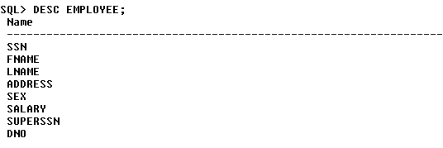

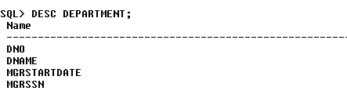

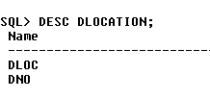

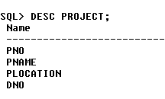

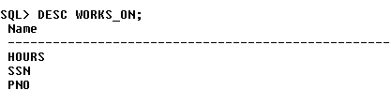

**Insertion of values to tables**

INSERT INTO EMPLOYEE (SSN, FNAME, LNAME, ADDRESS, SEX, SALARY) VALUES (‘RNSECE01’,’JOHN’,’SCOTT’,’BANGALORE’,’M’, 450000);

INSERT INTO EMPLOYEE (SSN, FNAME, LNAME, ADDRESS, SEX, SALARY) VALUES (‘RNSCSE01’,’JAMES’,’SMITH’,’BANGALORE’,’M’, 500000);

INSERT INTO EMPLOYEE (SSN, FNAME, LNAME, ADDRESS, SEX, SALARY) VALUES (‘RNSCSE02’,’HEARN’,’BAKER’,’BANGALORE’,’M’, 700000);

INSERT INTO EMPLOYEE (SSN, FNAME, LNAME, ADDRESS, SEX, SALARY) VALUES (‘RNSCSE03’,’EDWARD’,’SCOTT’,’MYSORE’,’M’, 500000);

INSERT INTO EMPLOYEE (SSN, FNAME, LNAME, ADDRESS, SEX, SALARY) VALUES (‘RNSCSE04’,’PAVAN’,’HEGDE’,’MANGALORE’,’M’, 650000);

INSERT INTO EMPLOYEE (SSN, FNAME, LNAME, ADDRESS, SEX, SALARY) VALUES (‘RNSCSE05’,’GIRISH’,’MALYA’,’MYSORE’,’M’, 450000);

INSERT INTO EMPLOYEE (SSN, FNAME, LNAME, ADDRESS, SEX, SALARY) VALUES (‘RNSCSE06’,’NEHA’,’SN’,’BANGALORE’,’F’, 800000);

INSERT INTO EMPLOYEE (SSN, FNAME, LNAME, ADDRESS, SEX, SALARY) VALUES (‘RNSACC01’,’AHANA’,’K’,’MANGALORE’,’F’, 350000);

INSERT INTO EMPLOYEE (SSN, FNAME, LNAME, ADDRESS, SEX, SALARY) VALUES (‘RNSACC02’,’SANTHOSH’,’KUMAR’,’MANGALORE’,’M’, 300000);

INSERT INTO EMPLOYEE (SSN, FNAME, LNAME, ADDRESS, SEX, SALARY) VALUES (‘RNSISE01’,’VEENA’,’M’,’MYSORE’,’M’, 600000);

INSERT INTO EMPLOYEE (SSN, FNAME, LNAME, ADDRESS, SEX, SALARY) VALUES (‘RNSIT01’,’NAGESH’,’HR’,’BANGALORE’,’M’, 500000);

INSERT INTO DEPARTMENT VALUES (‘1’,’ACCOUNTS’,’01-JAN-01’,’RNSACC02’);

INSERT INTO DEPARTMENT VALUES (‘2’,’IT’,’01-AUG-16’,’RNSIT01’);

INSERT INTO DEPARTMENT VALUES (‘3’,’ECE’,’01-JUN-08’,’RNSECE01’);

INSERT INTO DEPARTMENT VALUES (‘4’,’ISE’,’01-AUG-15’,’RNSISE01’);

INSERT INTO DEPARTMENT VALUES (‘5’,’CSE’,’01-JUN-02’,’RNSCSE05’);

**Note: update entries of employee table to fill missing fields SUPERSSN and DNO**

UPDATE EMPLOYEE SET

SUPERSSN=NULL, DNO=’3’

WHERE SSN=’RNSECE01’;

UPDATE EMPLOYEE SET

SUPERSSN=’RNSCSE02’, DNO=’5’

WHERE SSN=’RNSCSE01’;

UPDATE EMPLOYEE SET

SUPERSSN=’RNSCSE03’, DNO=’5’

WHERE SSN=’RNSCSE02’;

UPDATE EMPLOYEE SET

SUPERSSN=’RNSCSE04’, DNO=’5’

WHERE SSN=’RNSCSE03’;

UPDATE EMPLOYEE SET

DNO=’5’, SUPERSSN=’RNSCSE05’

WHERE SSN=’RNSCSE04’;

UPDATE EMPLOYEE SET

DNO=’5’, SUPERSSN=’RNSCSE06’

WHERE SSN=’RNSCSE05’;

UPDATE EMPLOYEE SET

DNO=’5’, SUPERSSN=NULL

WHERE SSN=’RNSCSE06’;

UPDATE EMPLOYEE SET

DNO=’1’, SUPERSSN=’RNSACC02’

WHERE SSN=’RNSACC01’;

UPDATE EMPLOYEE SET

DNO=’1’, SUPERSSN=NULL

WHERE SSN=’RNSACC02’;

UPDATE EMPLOYEE SET

DNO=’4’, SUPERSSN=NULL

WHERE SSN=’RNSISE01’;

UPDATE EMPLOYEE SET

DNO=’2’, SUPERSSN=NULL

WHERE SSN=’RNSIT01’;

INSERT INTO DLOCATION VALUES (’BANGALORE’, ‘1’);

INSERT INTO DLOCATION VALUES (’BANGALORE’, ‘2’);

INSERT INTO DLOCATION VALUES (’BANGALORE’, ‘3’);

INSERT INTO DLOCATION VALUES (’MANGALORE’, ‘4’);

INSERT INTO DLOCATION VALUES (’MANGALORE’, ‘5’);

INSERT INTO PROJECT VALUES (100,’IOT’,’BANGALORE’,’5’);

INSERT INTO PROJECT VALUES (101,’CLOUD’,’BANGALORE’,’5’);

INSERT INTO PROJECT VALUES (102,’BIGDATA’,’BANGALORE’,’5’);

INSERT INTO PROJECT VALUES (103,’SENSORS’,’BANGALORE’,’3’);

INSERT INTO PROJECT VALUES (104,’BANK MANAGEMENT’,’BANGALORE’,’1’);

INSERT INTO PROJECT VALUES (105,’SALARY MANAGEMENT’,’BANGALORE’,’1’);

INSERT INTO PROJECT VALUES (106,’OPENSTACK’,’BANGALORE’,’4’);

INSERT INTO PROJECT VALUES (107,’SMART CITY’,’BANGALORE’,’2’);

INSERT INTO WORKS_ON VALUES (4, ‘RNSCSE01’, 100);

INSERT INTO WORKS_ON VALUES (6, ‘RNSCSE01’, 101);

INSERT INTO WORKS_ON VALUES (8, ‘RNSCSE01’, 102);

INSERT INTO WORKS_ON VALUES (10, ‘RNSCSE02’, 100);

INSERT INTO WORKS_ON VALUES (3, ‘RNSCSE04’, 100);

INSERT INTO WORKS_ON VALUES (4, ‘RNSCSE05’, 101);

INSERT INTO WORKS_ON VALUES (5, ‘RNSCSE06’, 102);

INSERT INTO WORKS_ON VALUES (6, ‘RNSCSE03’, 102);

INSERT INTO WORKS_ON VALUES (7, ‘RNSECE01’, 103);

INSERT INTO WORKS_ON VALUES (5, ‘RNSACC01’, 104);

INSERT INTO WORKS_ON VALUES (6, ‘RNSACC02’, 105);

INSERT INTO WORKS_ON VALUES (4, ‘RNSISE01’, 106);

INSERT INTO WORKS_ON VALUES (10, ‘RNSIT01’, 107);

SELECT * FROM EMPLOYEE;

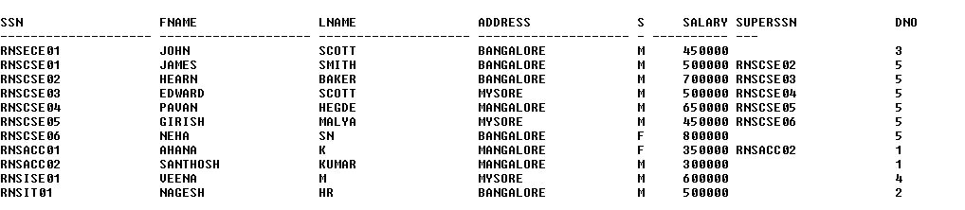

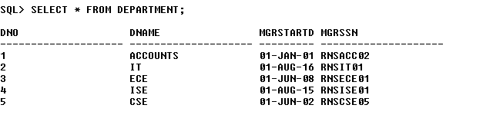

SELECT * FROM DLOCATION;



SELECT * FROM PROJECT;

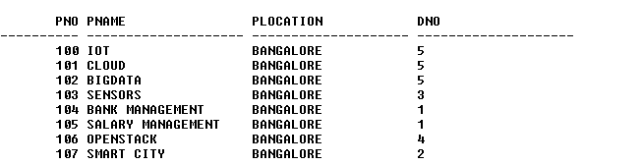

SELECT * FROM WORKS_ON;

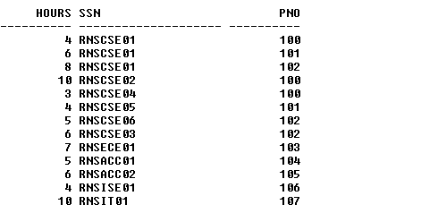

**Queries:**

1. **Make a list of all project numbers for projects that involve an employee whose last name is ‘Scott’, either as a worker or as a manager of the department that controls the project.**

(SELECT DISTINCT P.PNO

FROM PROJECT P, DEPARTMENT D, EMPLOYEE E

WHERE E.DNO=D.DNO

AND D.MGRSSN=E.SSN

AND E.LNAME=’SCOTT’)

UNION

(SELECT DISTINCT P1.PNO

FROM PROJECT P1, WORKS_ON W, EMPLOYEE E1

WHERE P1.PNO=W.PNO

AND E1.SSN=W.SSN

AND E1.LNAME=’SCOTT’);

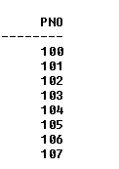

1. **Show the resulting salaries if every employee working on the ‘IoT’ project is given a 10 percent raise.**

SELECT E.FNAME, E.LNAME, 1.1*E.SALARY AS INCR_SAL

FROM EMPLOYEE E, WORKS_ON W, PROJECT P

WHERE E.SSN=W.SSN

AND W.PNO=P.PNO

AND P.PNAME=’IOT’;



1. **Find the sum of the salaries of all employees of the ‘Accounts’ department, as well as the maximum salary, the minimum salary, and the average salary in this department**

SELECT SUM (E.SALARY), MAX (E.SALARY), MIN (E.SALARY), AVG (E.SALARY)

FROM EMPLOYEE E, DEPARTMENT D

WHERE E.DNO=D.DNO

AND D.DNAME=’ACCOUNTS’;



1. **Retrieve the name of each employee who works on all the projects Controlled by department number 5 (use NOT EXISTS operator).**

SELECT E.FNAME, E.LNAME

FROM EMPLOYEE E

WHERE NOT EXISTS((SELECT PNO

FROM PROJECT

WHERE DNO=’5’ AND PNO NOT IN(SELECT PNO

FROM WORKS_ON

WHERE E.SSN=SSN));



1. **For each department that has more than five employees, retrieve the department number and the number of its employees who are making more than Rs. 6, 00,000.**

SELECT D.DNO, COUNT (*)

FROM DEPARTMENT D, EMPLOYEE E

WHERE D.DNO=E.DNO

AND E.SALARY>600000

AND D.DNO IN (SELECT E1.DNO

FROM EMPLOYEE E1

GROUP BY E1.DNO

HAVING COUNT (*)>5)

GROUP BY D.DNO;

